# **WAIKATO INSTITUE OF TECHNOLOGY**

## WINTEC – CENTRE FOR BUSINESS, INFORMATION TECHNOLOGY AND ENTERPRISE



I certify that this is all my own work, except for those parts identified for which references have been made.

**Submitted By: Submitted To:**

**Bikal Shrestha Dr. Ayesha Hakim**

**(17457903)**

**Gowtham Sethu Saravanan**

**(17458537)**

**Submission Date: Due Date:**

09/04/2018 09/04/2018

# Introduction

The Waikato Institute of Technology (WINTEC) is the leading institute providing quality education in New Zealand. The WINTEC has several departments (administration, student enrollment center, library and so on), faculties (Center for Beauty Therapy and Hairdressing, Center for Engineering and Industrial Design, center for Business, Information Technology & Enterprise etc.), faculty members, academic supervisor, industry partners, and industry relationship manager. The WINTEC has a current system to manage student, faculty members, and administrative staff and industry partners. The administrative process of student submitting expression of interest (EOI) which is then reviewed by WINTEC panel and set date for interview with student, identify suitable host based on the student skills portfolio, student writing initial proposal, signing the contract to work on project as an intern with the selected host is a cumbersome task with lots of paper work to be carried out. The WINTEC need enhancement in its system to leave out all paper works and digitized the above mentioned administrative tasks.

# About Web Application

​ ​ ​ ​ ​ A web application is a computer program that utilizes web browsers and web technology to perform tasks over the Internet. Millions of businesses use the Internet as a cost-effective communications channel. It lets them exchange information with their target market and make fast, secure transactions. However, effective engagement is only possible when the business is able to capture and store all the necessary data, and have a means of processing this information and presenting the results to the user.

Web applications use a combination of server-side scripts (PHP and ASP) to handle the storage and retrieval of the information, and client-side scripts (JavaScript and HTML) to present information to users. This allows users to interact with the company using online forms, content management systems, shopping carts and more. In addition, the applications allow employees to create documents, share information, collaborate on projects, and work on common documents regardless of location or device.

Web apps have several advantages over [desktop applications](https://techterms.com/definition/application). Since they run inside web browsers, developers do not need to develop web apps for multiple platforms. For example, a single application that runs in Chrome will work on both [Windows](https://techterms.com/definition/windows) and OS X. Developers do not need to distribute software updates to users when the web app is updated. By updating the application on the server, all users have access to the updated version.

**How the Web Application Works**

Web applications are usually coded in browser-supported language such as JavaScript and HTML as these languages rely on the browser to render the program executable. Some of the applications are dynamic, requiring server-side processing. Others are completely static with no processing required at the server.

The web application requires a web server to manage requests from the client, an application server to perform the tasks requested, and, sometimes, a database to store the information. Application server technology ranges from ASP.NET, ASP and ColdFusion, to PHP and JSP.

**Benefits of Web Application**

* Web applications run on multiple platforms regardless of OS or device as long as the browser is compatible
* All users access the same version, eliminating any compatibility issues.
* They are not installed on the hard drive, thus eliminating space limitations.
* They reduce software piracy in subscription-based web applications (i.e. SaaS)

**Example**

Web applications include online forms, shopping carts, word processors, spreadsheets, video and photo editing, file conversion, file scanning, and email programs such as Gmail, Yahoo and AOL. Popular applications include Google Apps and Microsoft 365

# ​Understanding Users

An understanding of users or stakeholder is crucial for understanding the system requirement. The requirement is key to the success of any project. The requirement can be defined as the clear cut description of the system to be developed – what it should do and what it should perform to achieve final user goals. Stakeholders refers to the people who will be affected by the implementation of the new system.

The key stakeholders of the WINTEC portal system are administrator, technical administrator, technical administrator, student, tutor, academic supervisor, industry clients, and industry relationship manager. The primary users are administrator, student, tutor and academic supervisor and the secondary users are industry clients, industry relationship manager.

## Primary Users

The primary users are as follows:

* **Student**: frequent user of system. Creates skills portfolio, fills expression of interest (EOI), find hosts, sign interest within set time frame, writing proposal
* **Administrator**: overall administration of the system, change of enrollment for successful student, award contract.
* **Technical Administrator**: manages the technical aspect of the administration and evaluate the work.

The secondary users are:

* **Industry Relationship Manager**: conduct meeting with identified hosts and find new host/industry clients.
* **Industry Clients**: provide internship opportunities to the student.

# Identify Needs

The need is what that determines whether new system is required or not. The needs can be identified after understanding the users and their context of use, observing the previous website (in our case say Wintec portal).

## Data Gathering

The main purpose of data gathering is to collect information of the various stakeholders of the system, their context of use, and the intended set of function to be achieved by the system so we can establish the requirement of the system. There are many techniques that we can use for data gathering purpose and they can be summarized as follows:

* Questionnaires
* Interviews
* Focus group and workshops
* Naturalistic Observation
* Studying documentation

We have applied focus group and workshops and studying documentation. We have conducted a series of meeting with the stakeholders where we got brief description of the requirements of the system. Besides these we also asked a series of questions where the requirements were not clear and we asked questions about the roles and responsibilities of each stakeholders. We were provided with documentation enlisting all the roles and responsibilities of stakeholders of the system and the intended tasks that each stakeholder needs to perform.

## Interaction Type

The different interaction type are as follows:

* Instructing
* Conversing
* Manipulating
* Exploring

In the WINTEC portal system instructing will be used as an interaction type where the user tells the system what to do. For example, for student say add portfolio, edit portfolio, update and delete portfolio and for technical administrator say add tutors, students, projects and other users.

# Establish Requirements

## Functional Requirement

The functional requirement of WINTEC portal system is shown below

|  |  |
| --- | --- |
| R.ID | Requirement Description |
| R1 | Login system for different user based on user privilege and user group |
| R2 | Students can update their profile information |
| R3 | Students can add, update and delete skills |
| R4 | Students can complete Expression of Interest (EOI) |
| R5 | Student can view details of industry partner |
| R6 | Student can view detail of academic supervisor |
| R7 | Students can upload cv |
| R8 | Student need to accept the contract and send signed contract |
| R9 | Technical Admin can CREATE, UPDATE, DELETE AND VIEW Existing and New TUTOR Profile |
| R10 | Technical Admin can CREATE, UPDATE, DELETE AND VIEW Existing and New STUDENT Profile |
| R11 | Technical Admin can CREATE, UPDATE, DELETE AND VIEW Existing and New PROJECTS |
| R12 | Technical Admin can CREATE, UPDATE, DELETE AND VIEW Existing and New USERS(ADMINS) |

## Non-Functional Requirement

The non-functional requirement is as follows:

|  |  |
| --- | --- |
| **R. ID** | **Requirement Description** |
| R1 | Enough memory space to hold all information of users and projects. |
| R2 | Response time of 400ms (milliseconds) for page load |
|  |  |
|  |  |

## Data Requirement

## Environmental Requirement

The WINTEC portal system must be available 24/7. As most of the users are student, tutors, administrator, technical administrator the system will be mostly used on the college premises. But they can also use from their homes, cafes and so on.

# User Profiles

The persona refers to an actual user of the application or website. An organization must recognize the actual persona and keep record of them so that they can plan and market to focus on those personas. The persona for this application keep tracks of different stakeholders’ information as follows:

* Name
* Gender
* Date of Birth
* Email Address
* Address (country, city, postcode)

The different type of persona of this system are:

* Student
* Technical Administrator
* Academic Supervisor
* Industry Relationship Manager
* Hosts
* Wintec Panel
* Industry Clients

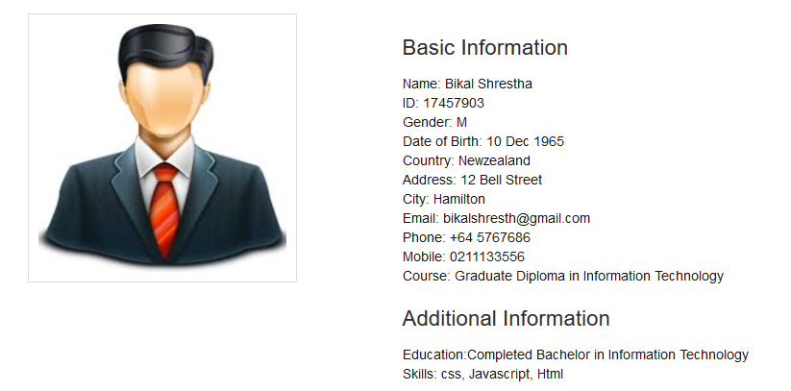

## Technical Administrator Persona

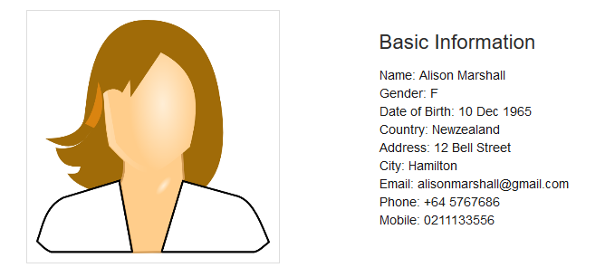

# Task Description

## Use Case Diagram

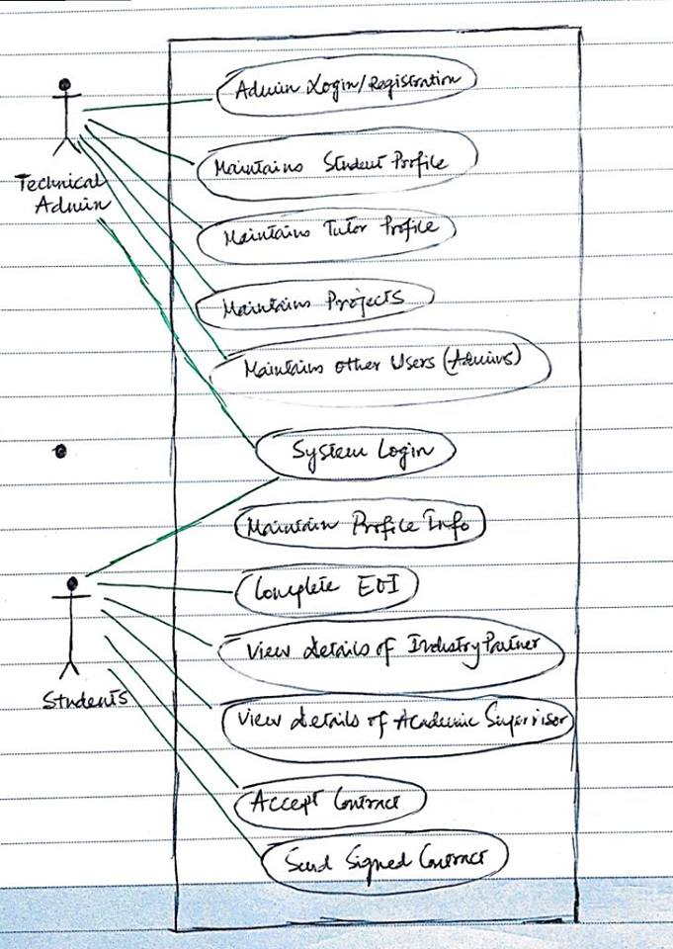

# REFERENCE

1. Wintec Moodle ( <https://learning.wintec.ac.nz/> ).
2. Student Portal ( <http://portal.sethu.ac.in/login/> ).

# GitHub Link

<https://github.com/gowthamsnrg/Assg1>